Here It Comes Again
Gazzara Plays Genesis

The long awaited follow up to Play Me My Song has finally arrived:
a new album entirely dedicated to the 1970’s music of Genesis

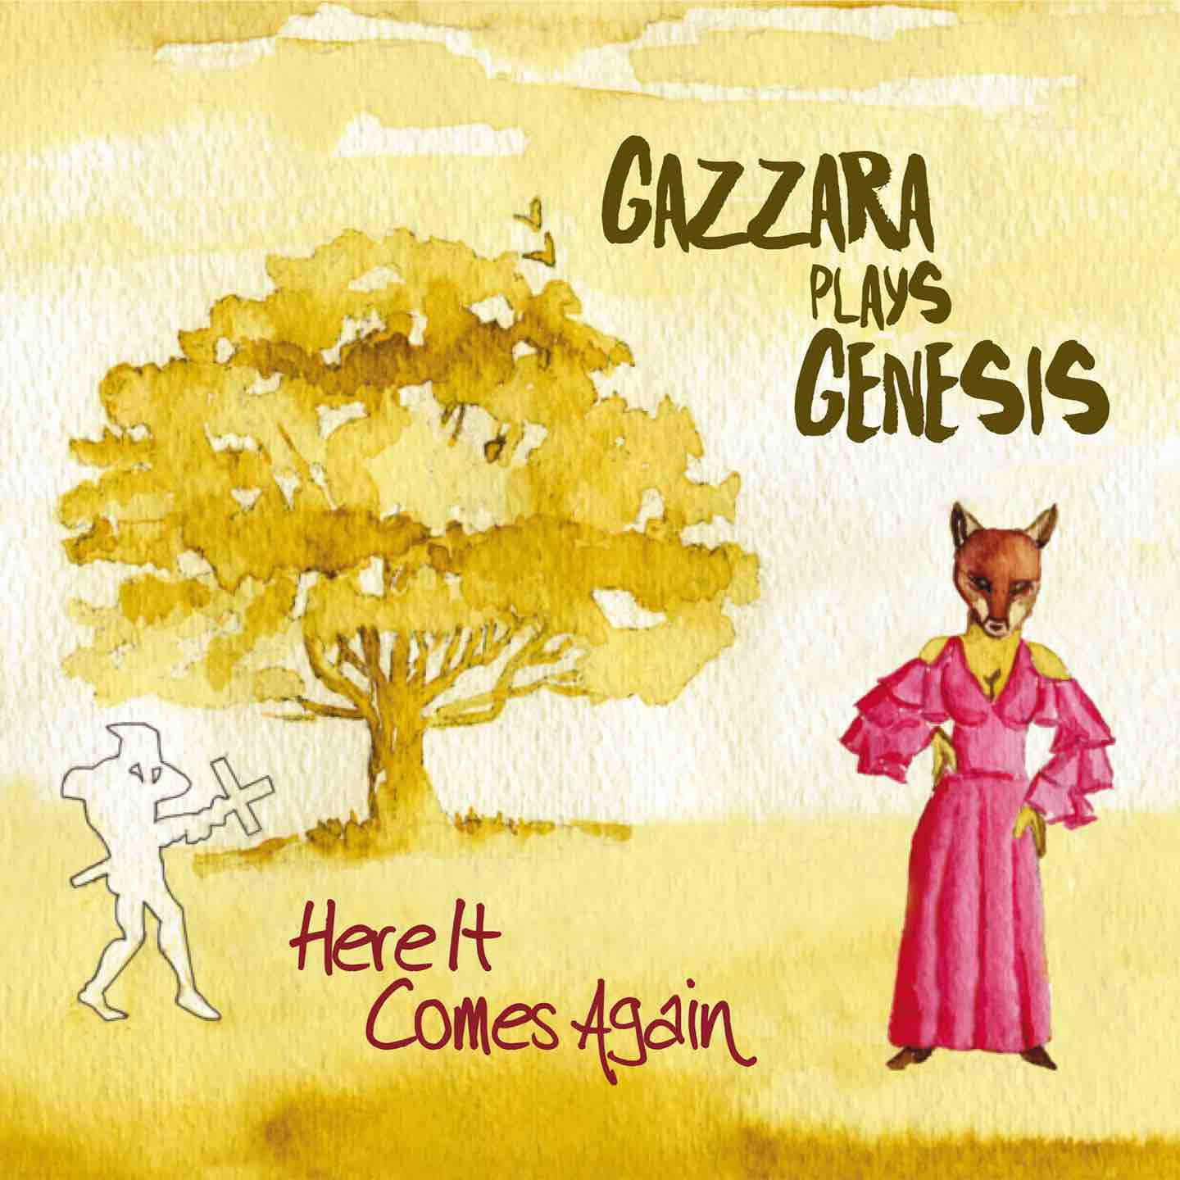
http://www.gazzaraplaysgenesis.com

“I enjoyed listening to Gazzara plays Genesis. It is beautifully played and has some really interesting arrangements” (Steve Hackett)

“This is a project that deserves to be well received” (Anthony Phillips)

“Francesco Gazzara ebbs and flows symphonically, reminiscent of early Genesis and Renaissance’s Annie Haslam style” (Dave Kennedy, Classic Rock Society)

It was January the 9th, 1970, when Genesis entered BBC Studios in London to record the first of three live sessions – the last one would take place later in May 1971. On the recording menu there were four tracks written for a documentary featuring artist Mick Jackson, this material would be largely used by the band for later albums such as Nursery Cryme and The Lamb Lies Down On Broadway. It was 9 months before Trespass was released and british prog rock was at its peak.
50 years later, in a rather symbolic date, Here It Comes Again the new acoustic and orchestral album by Gazzara Plays Genesis gets released (digipack CD and in all digital stores, IRMA Records label) celebrating once again the famous group with a number of revisitations for piano and orchestral ensemble arranged by italian pianist and composer Francesco Gazzara (Gazzara, The Piano Room, Hammond Express).

Following the success of 2014’s Play Me My Song, Gazzara Plays Genesis keeps the 1971-1980’s repertoire of the english band as the focus of his attention but adding some significant variations to the previous album. First one being the tracklist, filled with absolute gems – some of them never played live by Genesis as “Heathaze” (from Duke) and “Undertow” (from …And Then There Were Three) – and with a complete piano transcription of “Supper’s Ready” (23 minutes suite from Foxtrot). The second novelty comes from the album’s arrangements, richer in vintage sounds – Hammond organ, Mellotron, Rhodes piano, Arp synths, electric and acoustic guitars, bass pedals – always counterpointing the constant grand piano (a beautifully restored 1878’s Bechstein) and the orchestral instruments - mainly strings, reeds and horns – sharing the soloist role in each individual song.
Here It Comes Again (a quote from “The Musical Box” lyrics, Play Me My Song being the first half of the same verse) is an album full of detail: once again moving away from the usual “Genesis for piano” formula, the project keeps building a sort of imaginary soundtrack where so many details of the original masterpieces - even some of the hidden ones, hard to hear without a pair of decent headphones - have been painstakingly brought up to the surface and assigned to other unusal instruments.
The album’s tracklist flows in chronological order, starting from “The Musical Box” – with guests musicians David Giacomini (electric guitar), Dario Cecchini (flute) and Valerio Sanna (clarinet) – and moving suddenly into the seven sections of “Supper’s Ready” with a kaleidoscopic arrangement made of vintage keyboards and some more unusual instruments as melodica and tubular bells. “I Know What I Like (In Your Wardrobe)” – the very first Genesis attempt at “Top Of The Pops”, dated 1973 – is also a chance for Gazzara Plays Genesis to introduce a rhythmic section: Mauro Mirti on cajon and Massimo Sanna on electric bass. David Giacomini’s electric guitar features again in “The Carpet Crawlers”, with his special sound reminiscent of both Steve Hackett and Robert Fripp. Moving the tracklist to the “Phil Collins era” of Genesis we enter the magnificent opening to “Dance On A Volcano” with Gulia Nuti on viola, also soloing at the end with a riff from “Baba O’ Riley” by The Who. You’re not acquainted with A Trick Of The Tail yet and the whole piano intro to The Lamb Lies Down On Broadway – a Tony Banks masterpiece – hits you fast before descending into a quick end quoting the first few notes of “Ripples”: a tribute to that magic “medley art” of Genesis. The following three songs benefit from strings treatment: “Eleventh Earl Of Mar” with guest violinist Fabrizio Paoletti, “Afterglow” with cellist Giogia Pancaldi (both tracks originally from Wind&Wuthering) and “Undertow” (from …And Then There Were Three…) with double bassist Stefano Corato. The end of the album is dedicated to Duke, with the return of guest Dario Cecchini switching from flute to soprano sax for “Heathaze” (another Tony Banks penned gem) and with the solo piano closing number “Guide Vocal”.
Last but not least Here It Comes Again’s graphic project: as for Play Me My Song the new album (gatefold) sleeve is enhanced once again by a watercolor painting by artist Ugo Micheli, inspired by the original works of Paul Whitehead, Colin Elgie (Hypgnosis) and Lionel Koechlin.
Francesco Gazzara is ready with his piano recital, including both Gazzara Play Genesis album tracklists, another deep journey through oniric and cinematographic atmospheres, with a bit of english country thrown in the middle...

Info: www.gazzaraplaysgenesis.com
Booking: info@gazzaraplaysgenesis.com

